##### 

##### CASSANDRE MATELASSÉ SMALL ENVELOPE WALLET

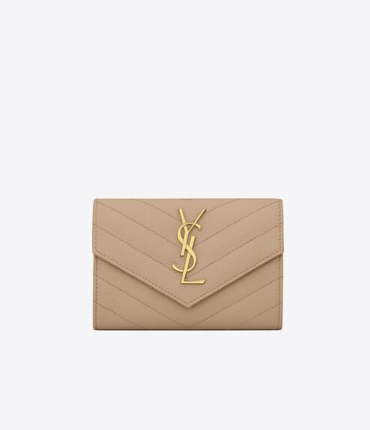  
The "Cassandre Matelassé Small Envelope Wallet" is a stylish accessory offered by Saint Laurent, a renowned luxury fashion house. This wallet is part of the Cassandre collection, known for its sleek design and signature YSL monogram detail.

Here's what you can expect from the Cassandre Matelassé Small Envelope Wallet:

1. **Matelassé Design**: The term "matelassé" refers to a quilted or padded design. In the case of this wallet, it likely features a quilted pattern that adds texture and visual interest to the exterior.
2. **Small Size**: As indicated by its name, this wallet is small in size, making it ideal for carrying essential items such as cards, cash, and coins. Its compact design makes it convenient for slipping into smaller bags or pockets.
3. **Envelope Style**: The wallet is designed in an envelope style, featuring a flap closure that secures with a snap or button. This design not only adds a chic touch but also ensures the safety of your belongings.
4. **YSL Monogram**: The wallet is adorned with the iconic YSL monogram detail, which serves as both a decorative element and a symbol of luxury and sophistication.
5. **Interior Organization**: Despite its small size, the wallet is typically designed with multiple compartments, slots, and pockets to help you organize your cards, cash, and coins efficiently.

If you're interested in purchasing the Cassandre Matelassé Small Envelope Wallet, you can explore Saint Laurent's official website or visit their boutique stores to see the latest offerings. Additionally, you can check with reputable luxury retailers or online platforms specializing in designer accessories to find this specific wallet.